The MicroGlia  By Kathy Miller  Assembly photos by Kathy Miller  Static and Flight photos by Buzz Nau.  Parts List  1 Estes PNC20 nosecone  10” Estes PNC20 airframe  18mm engine stop  3/32” balsa for fins  3 Styrofoam eggs 1 7/8” x 2 ½” for fin pods  white glue or glue usable with foam  Gorilla glue  1/8” x 24” elastic shock cord  1” x 15” streamer  Assembly  Start by cutting the BT20 to 10” length. Glue the motor block into place using a spent motor casing, pushing the block into the tube until ½” of the motor sticks out. Quickly remove motor. Let dry.  Cut three fins from the 3/32” balsa, being careful to align the arrow with the grain of the balsa. Carefully sand fin edges, slightly rounding outer edges.  To make the fin pods. Cut the three foam eggs in half lengthwise and carefully trim off the top and bottom to make a rough square shape, rounding around the top edge. Don’t round the back flat part as this is the side attaching to the fin. When all six halves are shaped, glue into place on fin surfaces making sure pods match up on both sides of the fins. Resand to match.  After pods have dried onto fins there will be a gap between the top of the pods. I used Gorilla Glue to fill the space. After it expands and sets, sand to match the contour of the pods. After all glue has set and shaping is complete, coat with four coats of foam glue, letting dry between coats. | 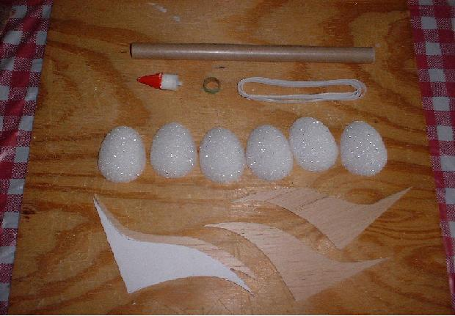  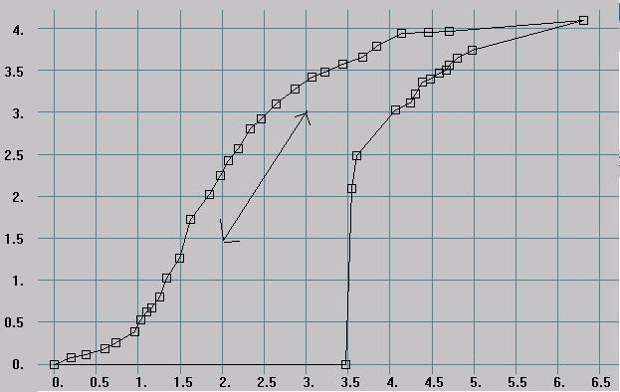  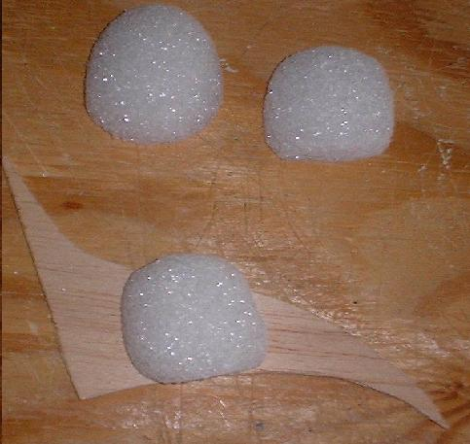
Mark the body tube at 120-degrees for fin placement. When pods are dry, glue fins to the body tube one at a time, insuring fin is straight and glue dry before proceeding to next fin.  Attach the launch lug against the upper edge of a fin at the fin/bt joint. Fillet the launch lug and fins. Make the shock cord mount in typical Estes fashion cutting out a narrow strip of paper making the tri-fold mount and then gluing it at least 1” into the body tube. Tie the other end to the nosecone. Attach the streamer 2” from the nosecone.  Finishing  Cover the entire rocket with light grey primer or white satin Krylon. Paint red, leaving about ½” tip of the nosecone and ½” from the top of the pods to the bottom of the rocket white. Paint the outer edges of the fins red. Using a black paint pen, paint the details on the nosecone and pods using the photos as a guide.  Flights  The MicroGlia has had two successful flights a recent JMRC launch. First on a 1/2A6-2 for a straight up boost with an apogee deployment of about 80’ and a soft recovery nearby. The second flight was on an A8-3 to about 220’, again, straight up with apogee ejection and another soft and close landing. The third flight was on a B4-4 to about 600’ and a bit of a walk for retrieval. | 